LBYCPA1

**Programming Logic and Design Laboratory**



*(Note: you can change the image to your own liking)*

**Laboratory Module 4**

Control Structure – Loops

By

John Carlo Theo S. Dela Cruz | LBYCPA1 | EQ1

# INTRODUCTION

Fourth Module of this course will mainly focus on Control Structures more specifically looping statements. According in the module 4, Looping statements is a flow control statements that are always present in every aspect in the programming field; it is widely used and incredibly important. Looping from the word loop, it executes the same code within a specific condition or number of times. A basic differentiation between while and for loop is: While loop statement loops a certain code within a certain condition is satisfied or is true, and For loop statement repeats the code within a certain range. In this module, we will be focusing ourselves on how we can use the looping statements and use these statements to create a program with the knowledges from our past modules.

The main objective of every laboratory report is to provide opportunity for learning and to provide challenging experience in the field of programming despite the hindrance of the Pandemic. Through the process of programming alongside with the method of planning; algorithms, pseudocodes and flowcharts that provides systematic process on how the program works. Python is a very powerful and flexible language, and we are responsible to plan how the program will work. This module would be a big challenge for us aspiring software developers since this module would challenge us to further use the loop statements.

**What do you think are the main objectives for this module? (Enumerate as many as you can.)**

1. Objectives
2. To familiarize with the use of FOR and WHILE Looping statements
3. To generate arithmetic progression using the range () function
4. To solve computational problems using looping statements
5. To use and adapt the knowledge in Looping Statements with the use of Karel the Bot.

**What are the materials used for this module?**

1. Materials and Tools
2. Instructor's lecture notes
3. Jupyter Notebook
4. Diagrams.net
5. Karel the Bot
6. Pycharm.edu
7. Google Browser

# PROCEDURES (*Individual*) / EXPERIMENTAL PLAN

In every experimental plan of every Laboratory Report we always place our initial plans before performing executing our codes, in programming we always use Pseudocodes / Algorithms or Flowcharts, as a representation of how we can show the separate steps of each process in a sequential manner.

1. Familiarization Exercise 1 # Stairs:
2. Familiarization Exercise 2 chuchu:
3. Familiarization Exercise 3 AND, OR, and NOT:
4. Familiarization Exercise 4 Hourglass using Karel Bot:

**The Introduction together with individual Procedures and plan comprises the Experimental Plan and Conducting Experiment/ Activity criteria in the Final Laboratory Report Rubric**:

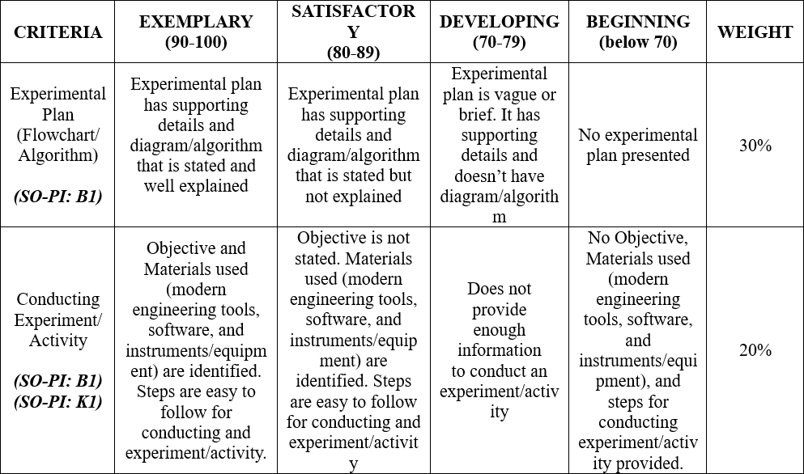

# RESULTS AND DISCUSSION/COMPUTATIONS (*Include the program output screenshots, and discussions per problem solution*)

1. Familiarization Exercise 1 # Stairs:

Explanation:

1. Familiarization Exercise 2 chuchu:

Explanation:

1. Familiarization Exercise 3 AND, OR, and NOT:

Explanation:

1. Familiarization Exercise 4 Hourglass using Karel Bot:

Explanation:

**The Results and Discussions constitutes the data criteria in the Lab Report Evaluation Rubric**:

# CONCLUSION:

The Conclusion returns to the larger purpose of the lab, which is presented as the learning context in the Introduction: **to learn something about the scientific or computational concept that provides the reason for doing the lab**. This is where you demonstrate that you have indeed learned something by stating what it is you have learned. This is important because it helps you to understand the value of the lab and convinces the reader that the lab has been a success. It's important, then, to be specific, providing details of what you have learned about the theory or principle or procedure at the center of the lab. The following guides questions should be answered to create a good conclusion:

**Did you achieve your objectives for this module? Describe your achievement in this module one-by-one, objective by objective. Ideally, each objective has its own paragraph.**

**What have you learned? Both technically (focused on programming), and in general (soft skills, attitude-related, etc.)**

**What are the common pitfalls, mistakes, and confusion that you have encountered? How did you overcome them?**

**What are your recommendations for those who will try the activity for the first time and what can you suggest to improve this module?**

**The rest of the rubric criteria are as follows:**

# REFERENCES (*Enumerate references in APA format*)

w3school (n.d.). Retrieved from. https://www.w3schools.com/python/python_intro.asp

stackOverflow (n.d.). Retrieved from. <https://stackoverflow.com/>

DelftStack (May 9, 2021). Retrieved from. <https://www.delftstack.com/howto/python/python-remove-newline-from-string/>

# APPENDIX (*Attach all the source codes here per problem category*)

1. Familization Exercise 1: